**JOBSHEET 02 Class and Object**

Muhammad Tegar Hibatulloh

22 / 2341720221 / 2I

Link github: <https://github.com/Garrss/Pemrogramman-Berbasis-Objek-Jobsheet/tree/main/Week2>

**4.1 Experimental 1: Creating Class Diagram**

Case study 1:

In a company, one of the data that is processed is employee data. Each employee has an id, name, gender, title, title and salary. Each employee can also view personal data and see his salary.

1. Describe the class diagram design from case study 1 !,

|  |
| --- |
| Employee |
| * id: int * name: string * gender: string * title: string * salary: double |
| + viewPersonalData(): void  + viewSalary() : float |

1. Mention what classes can be made from case study 1 !,

Employee

1. Mention the attributes and data types that can be identified from each class from case study 1!

* id: int (a unique identifier for each employee).
* name: string (the full name of the employee).
* gender: string (the gender of the employee).
* title: string (the job title of the employee).
* salary: float (the salary of the employee).

1. Mention the methods that you created from each class in case study 1!

* viewPersonalData() : void (This method will display the personal data (id, name, gender, and title) of the employee.
* viewSalary(): float (This method will return the salary of the employee.

**4.2 Experimental 2: Create and accesing the member of a class**

Case study 2:

Look at the class diagram below. Make a program based on the class diagram!

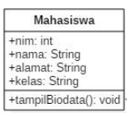

Scaffolding:

1. Open the text editor/ IDE ex: Notepad ++ / netbeans.

2. Write the code below :

3. Save it into Mahasiswa.java.

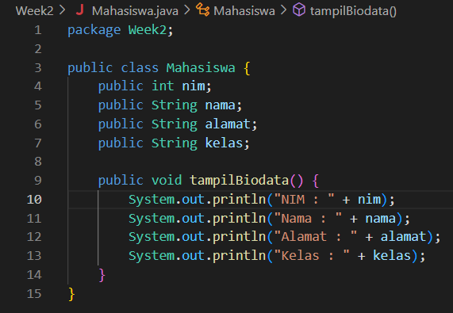

4. To access the members of an object, the instance of the class must be created first. To

show how to access the members of the Student class, let’s create a new file and then

typing the following program code:

5. Save it into TestMahasiswa.java

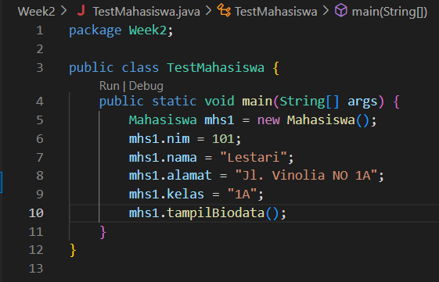

6. Run the TestMahasiswa class

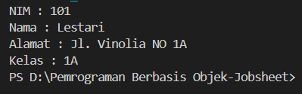

7. Based on the code, please explain in which line the attribute declaration was?

Mahasiswa class:

* Lines 2 until 5
* public int nim;
* public String nama;
* public String alamat;
* public String kelas;

8. Based on the code, please explain in which line the method declaration was?

Mahasiswa class on line 7:

* public void tampiBiodata()

9. How many objects instantiate from the code?

Only one object which is Mhs1

* Mahasiswa mhs1 = new Mahasiswa();

10. What does this line “mhs1.nim=101” mean?

* To assign the value 101 to the nim attribute (or field) of the mhs1 object, which is an instance of the Mahasiswa class.

11. What does this line “mhs1.tampilBiodata()” do?

* To calls the “tampilBiodata” method of the mhs1 object, which is an instance of the Mahasiswa class.

12. Please instantiate 2 more object, by adding more code!

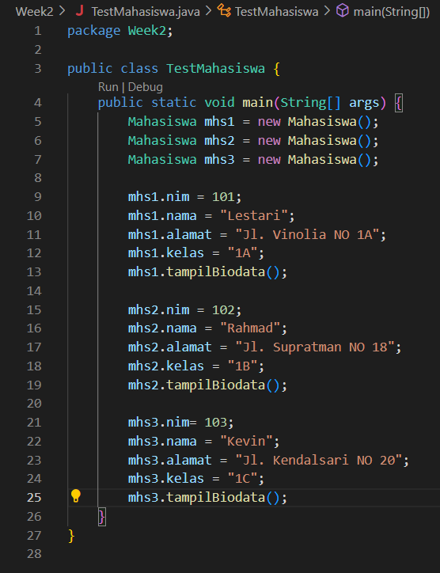

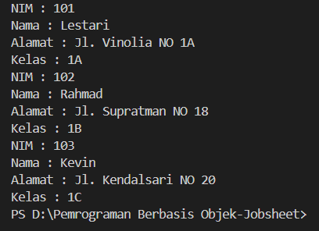

**4.3 Experimental 3: Writing method that has a return value Scaffolding:**

1. Open the text editor/ IDE ex: Notepad ++ / netbeans.

2. Write the code below:

3. Save into Barang.java

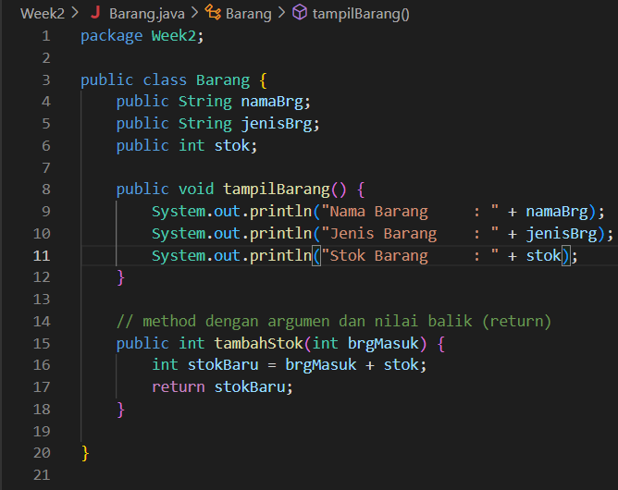

1. To access the members of an object, the instance of the class must be created first. To

show how to access the members of the barang class, let’s create a new file and then

typing the following program code:

2. Save intoTestBarang.java

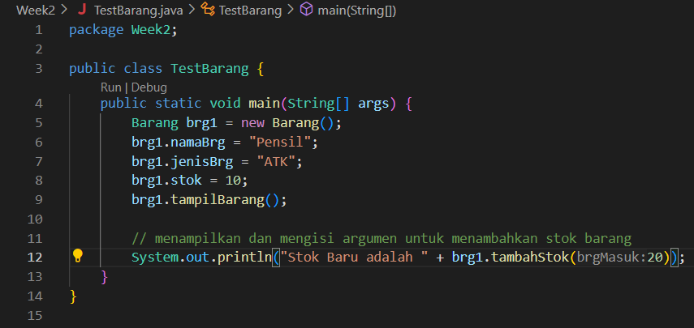

3. Run the code!

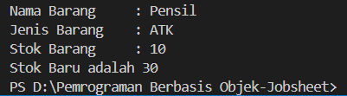

4. What is the function of an argument in a method?

* The function of the argument is to allow the method to receive input data from the outside, which can then be used in the method's calculations or operations.

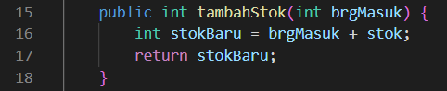

The argument brgMasuk is passed to the method when it is called

Brg1.tambahstok(20);

5. Makes conclusion on “return” keyword, when should we used it?

Is used within a method to exit the method and send a value back to the calling code. It essentially defines the output of the method and terminates its execution.

* For void method: exit the method early: Use return to stop method execution prematurely when no value is returned
* For non-void method: Return a value: When a method has a return type (e.g., int, String), it must use return to return a value that matches the method's return type.

**4.2 Assignments**

1. One of the video game rental shops process is borrowing, The stored data when someone renting the game are the id, member name, game name, and the amount to pay. Each rent can display the data and the amount to pay. Make a class diagram based on the case study!

explanation:

• The price amount will be coming from price per day times renting duration!

• Assume that 1 transaction will only consist of 1 game.

|  |
| --- |
| Rental |
| * id: int * gameName: String * memberName: String * rentDuration: int * price: double |
| + calculateAmountPay(): double  + displayData(): void |

1. Create the code based on the case study no 1!

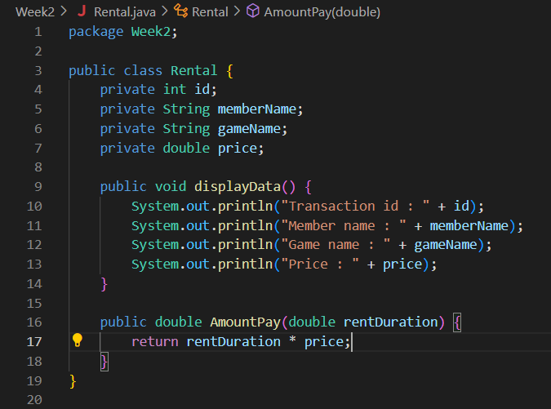

1. More exercise, please create the code from the following class diagram:

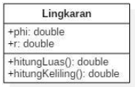

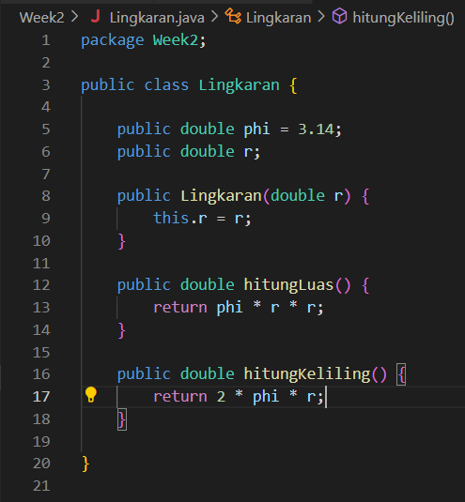

1. More exercise, please create the code from the following class diagram:

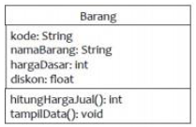

Description:

• The hargaDasar attribute is in Rupiah and the discount atribute in percentage!

• The hitungHargaJual() method used to calculate the based price by following this

rule

Selling price (hargaJual)= base price(hargaDasar) – (discount(diskon) x base price

(hargaDasar))

• The tampilData() Method will be used to show the value of each class attribute:e

kode, namaBarang, hargaDasar, diskon dan harga jual.

